**Based On SAT Exercises**

**Vocabulary 3**

1. **Immense - extremely large in size or degree.**

Sentence example - They spent an immense amount of time getting the engine into perfect condition.

1. **Showcase - exhibit; display.**

Sentence example - The albums showcase his production skills.

1. **Glacier - a large mass of ice that moves slowly.**

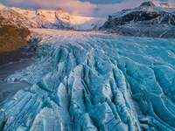

1. **Cavity - a hole, or an empty space between two surfaces.**

Sentence example - The gold was hidden in a secret cavity.

1. **Graft - a piece of healthy skin or bone cut from one part of a person's body and used to repair another damaged part, or a piece cut from one living plant and attached to another plant so that it grows there.**

Sentence example - He has had a skin graft on his badly burned arm.

1. **Scaly - If skin is scaly, it has small, hard, dry areas that fall off in small pieces.**

Sentence example - I get scaly patches on my scalp.

1. **Oral - spoken and not written.**

Sentence example - They had reached an oral agreement.

1. **Uneven - not level, equal, flat, or continuous.**

Sentence example - Be careful on that path - the paving stones are uneven.